
MCL360 MICROPROCESOR UPGRADE INSTRUTIONS

Required elements:
Atmel_ICE programmer box.
Microchip Studio Suite and drivers installed in the computer.
SmartCom software for PC and Android App.
MF232 serial cable for Lantern programing.
INSTRUCTIONS.
- Open the lantern from the top part and remove the power cable in the flasher.
- Select the DIP-1 in ON position for firmware upgrade.
- Plug the programmer flat cable connector in the Flasher upgrade port “BOOT”. Pay attention to the circuit marks for the position cable/socket.
- Connect the power supply cable to the flasher circuit.

- Select in “Tool” your Atmel_ICE programmer box connected in the computer.

- Select the flasher microprocessor Device in the List:
MCL360 MICROPROCESOR MODEL: ATSAML21J18B.
Interface SWD.
- Press “Apply” to connect PC with the flasher and press read to check if the 3.3V is present in the circuit.
- Select “Memories” and find the new firmware file in your computer. Press “Program” to start the process. Select Erase and Verify options:

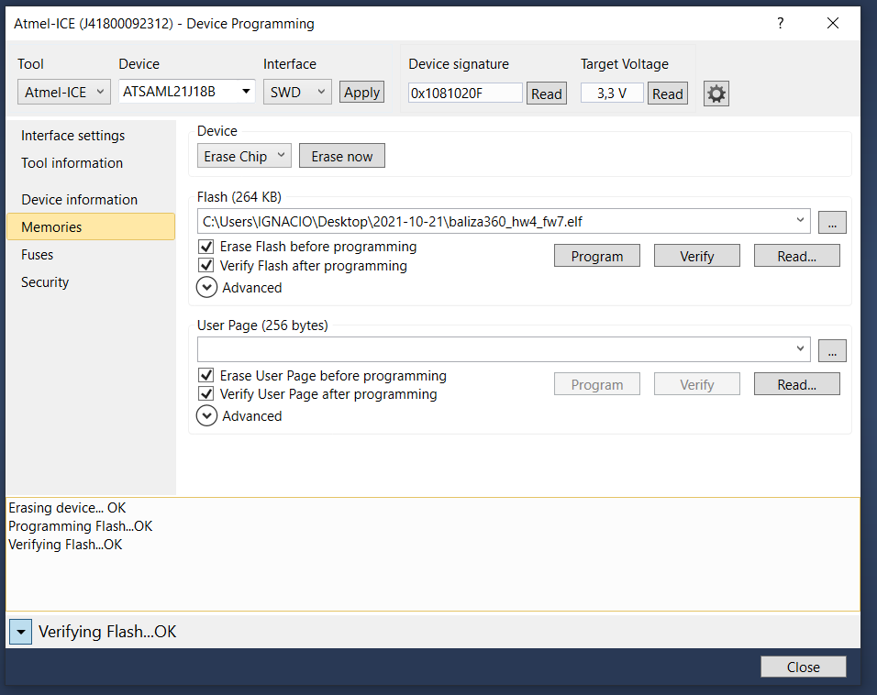

After finish the verifying process will display a confirmation message as the screen.RE
- Remove the power cable to the flasher and select DIP1=Off for normal operation.
- Disconnect the programmer box from the flasher “BOOT” port.
- Plug again the power supply cable for start the normal operation in the lantern.

PROGRAMING AND TESTING PROCES
- Use the software SMARTCOM in your computer or Android for configure and test the lantern.
- Check in Status the Firmware version in use to confirm the upgrade process success.
- Check and program the lantern according to your requirements following the instruction in the SmartCOM User Manual.

MICROCHIP LINK:
https://www.microchip.com/en-us/development-tools-tools-and-software/microchip-studio-for-avr-and-sam-devices#Downloads

